**IBM Assignment -2**

**Pharma Sales Dashboard**

|  |  |
| --- | --- |
| Assignment Date | 18 September 2022 |
| Student Name | GIFTY SHARON K |
| Student Roll Number | 953619104012 |
| Maximum Marks | 2 Marks |

**Task 1: Sales By Customer**

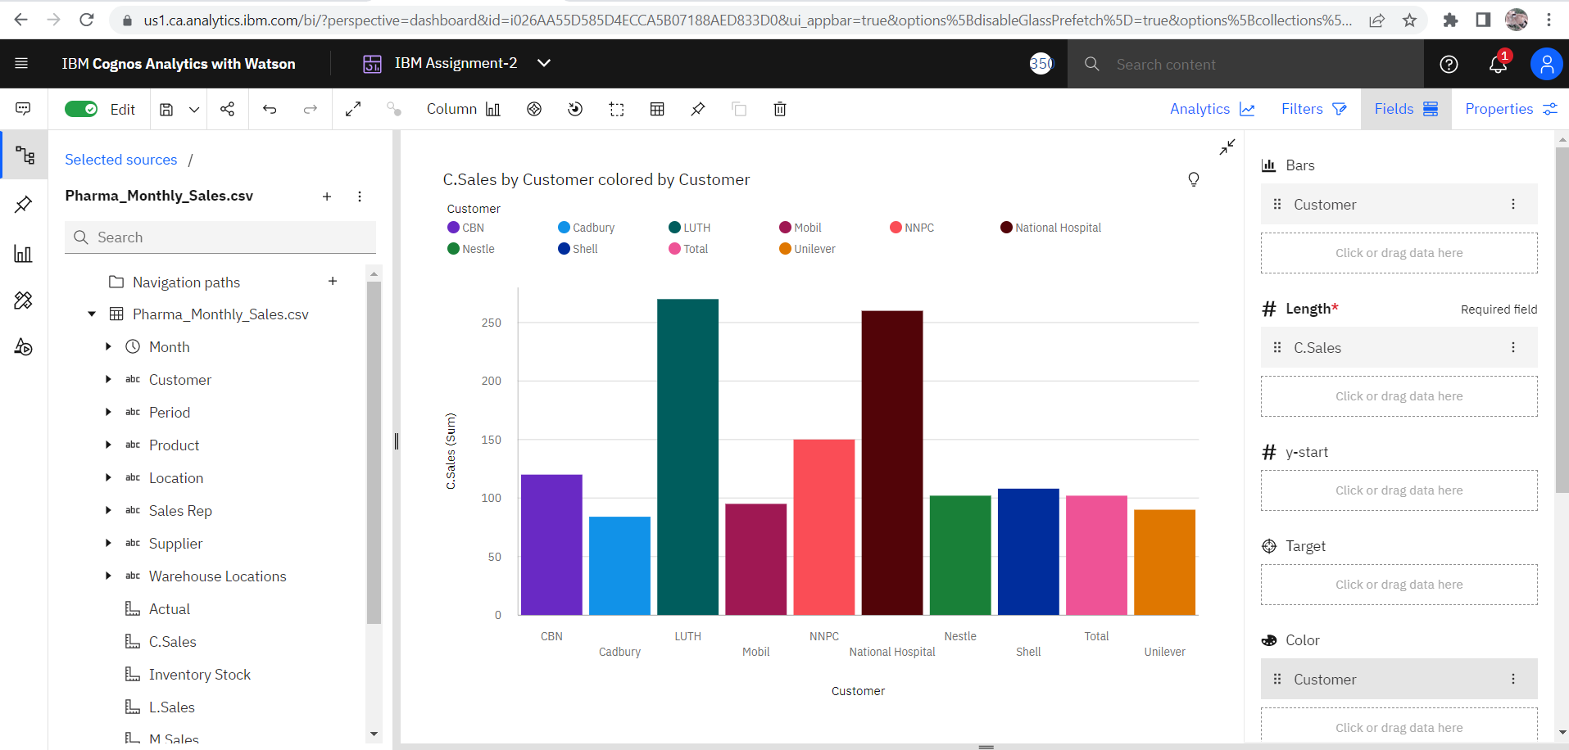

**Task 2: Sales By Location**

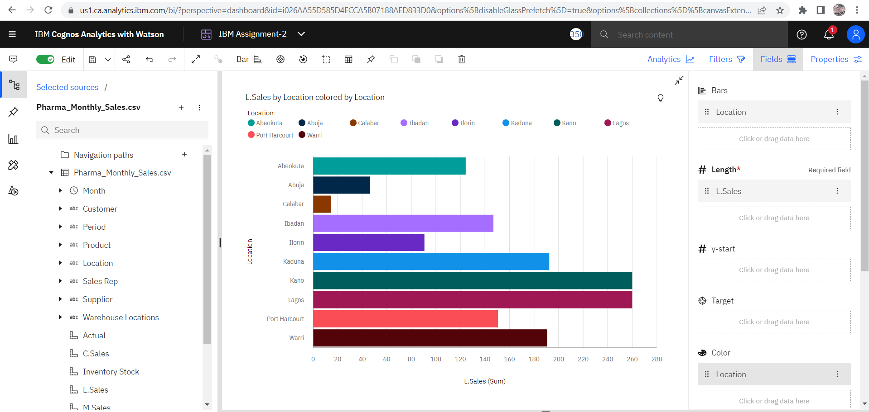

**Task 3: Sales By Sales Representative**

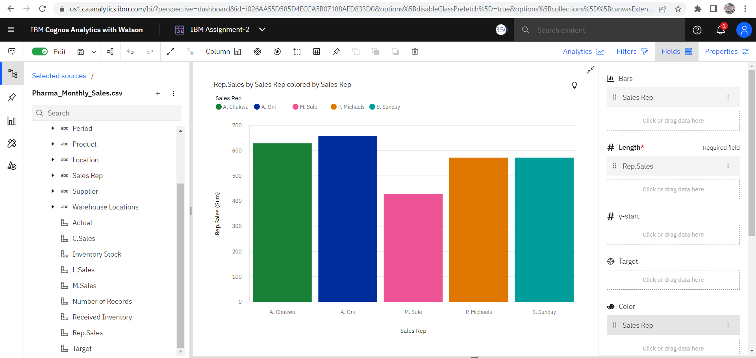

**Task 4: Received Inventory From Supplier**

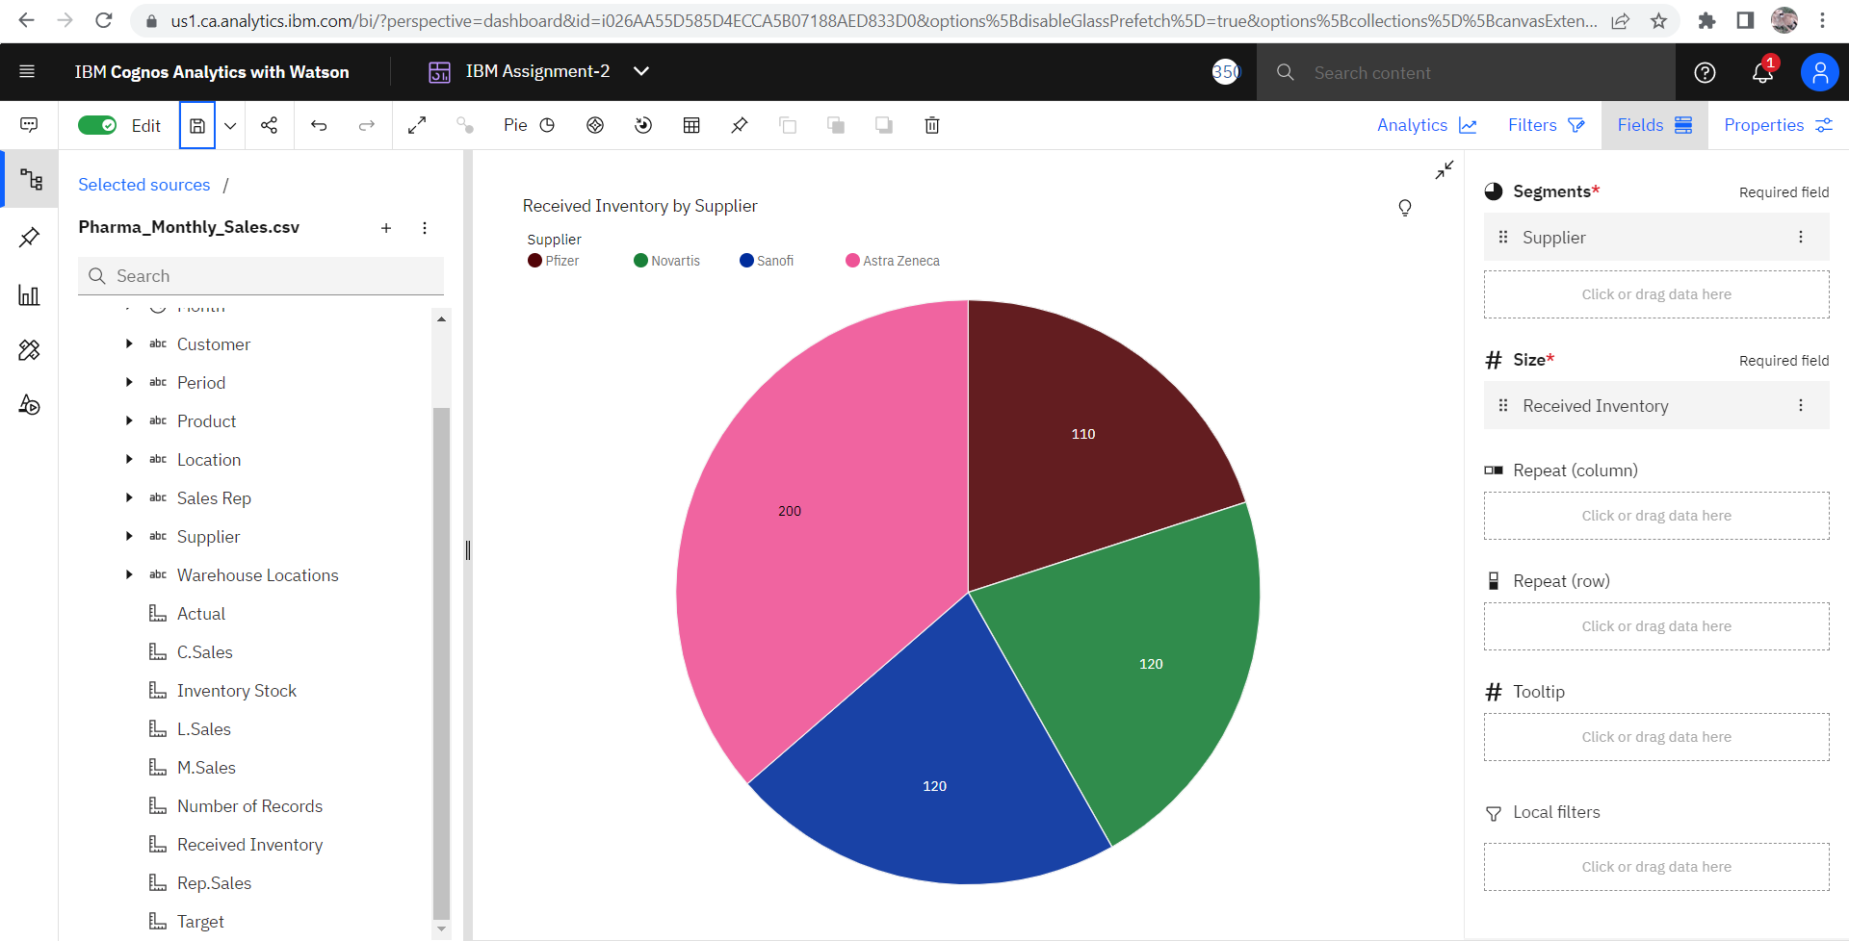

**Task 5: Inventory Stock for Warehouse Locations**

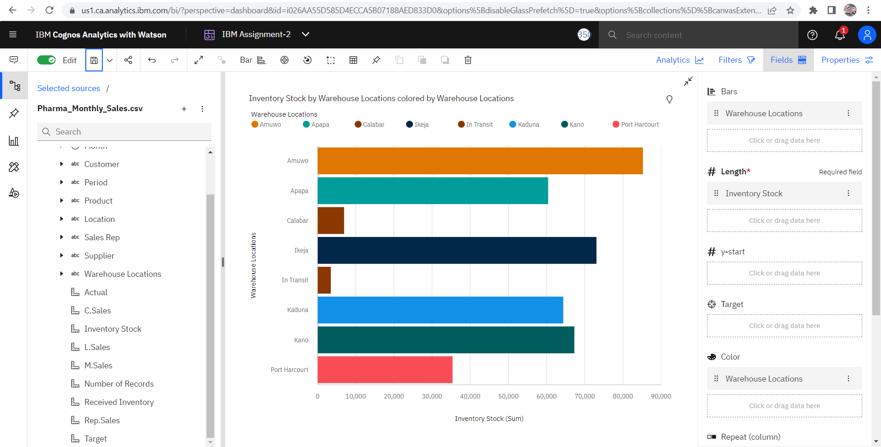

**Task 6: Sales Trend**

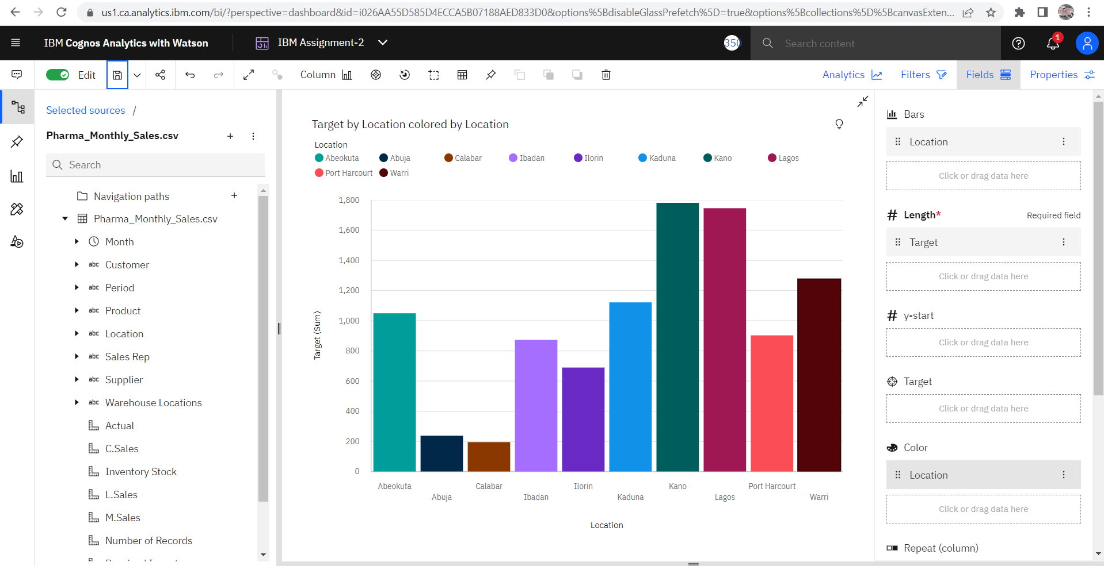

Considering the target, the target is dependant on the location as Kano, Lagos tops the target. They have also topped the sales by location. Since their location sales is high, they have achieved the target higher than any other location.

**Task 7: Monthly Sales**

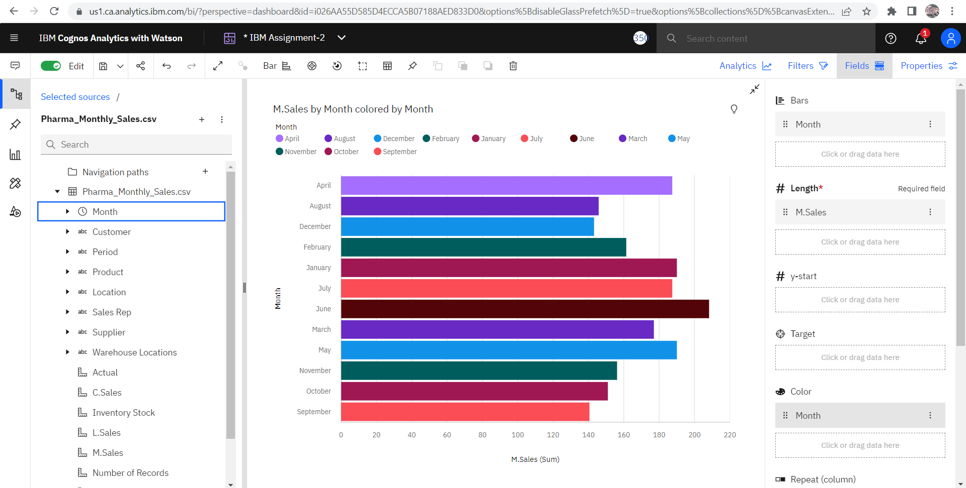

**Task 8: Actual and Received Inventory by Month**

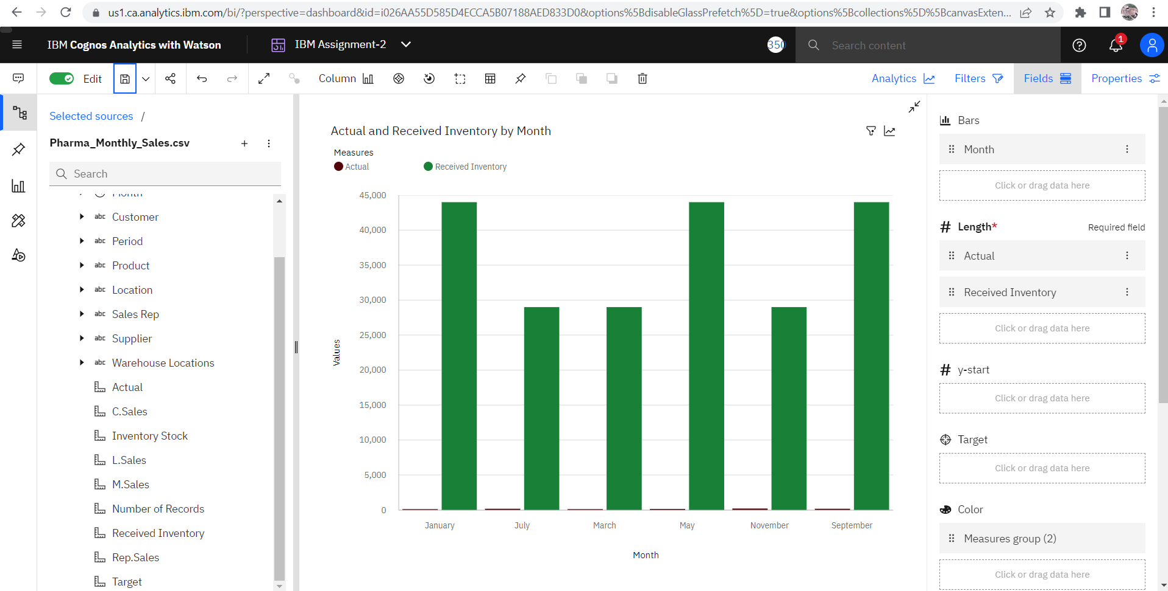

Link for the Dashboard : <https://us1.ca.analytics.ibm.com/bi/?perspective=dashboard&pathRef=.my_folders%2FIBM%2BAssignment%2FIBM%2BAssignment-2&action=view&mode=dashboard&subView=model0000018380068ed6_00000002>